**Experiment 2**

**Aim:** Identify suitable Agent Architecture and type for the problem.

**Objective:** To study the structure, characteristics of intelligent agent and identify the type of any rational agent.

**Theory:**

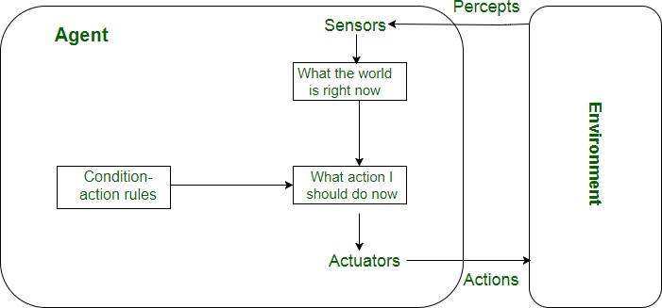

**Simple Reflex agent:**

* The Simple reflex agents are the simplest agents. These agents take decisions on the basis of the current percepts and ignore the rest of the percept history.
* These agents only succeed in the fully observable environment.
* The Simple reflex agent does not consider any part of percepts history during their decision and action process.
* The Simple reflex agent works on Condition-action rule, which means it maps the current state to action. Such as a Room Cleaner agent, it works only if there is dirt in the room. **Model-based reflex agent:**
* The Model-based agent can work in a partially observable environment, and track the situation.
* A model-based agent has two important factors: o **Model:** It is knowledge about "how things happen in the world," so it is called a Model-based agent. o **Internal State:** It is a representation of the current state based on percept history.
* These agents have the model, "which is knowledge of the world" and based on the model they perform actions.
* Updating the agent state requires information about:
  + How the world evolves
  + How the agent's action affects the world.

**Goal-based agents** o The knowledge of the current state environment is not always sufficient to decide for an agent to what to do.

* The agent needs to know its goal which describes desirable situations.
* Goal-based agents expand the capabilities of the model-based agent by having the "goal" information.
* They choose an action, so that they can achieve the goal. o These agents may have to consider a long sequence of possible actions before deciding whether the goal is achieved or not. Such considerations of different scenario are called searching and planning, which makes an agent proactive.

**Utility-based agents** o These agents are similar to the goal-based agent but provide an extra component of utility measurement which makes them different by providing a measure of success at a given state.

* Utility-based agent act based not only goals but also the best way to achieve the goal.
* The Utility-based agent is useful when there are multiple possible alternatives, and an agent has to choose in order to perform the best action.
* The utility function maps each state to a real number to check how efficiently each action achieves the goals.

**Learning Agents**

* A learning agent in AI is the type of agent which can learn from its past experiences, or it has learning capabilities.
* It starts to act with basic knowledge and then able to act and adapt automatically through learning. o A learning agent has mainly four conceptual components, which are:
  1. **Learning element:** It is responsible for making improvements by learning from environment
  2. **Critic:** Learning element takes feedback from critic which describes that how well the agent is doing with respect to a fixed performance standard.
  3. **Performance element:** It is responsible for selecting external action
  4. **Problem generator:** This component is responsible for suggesting actions that will lead to new and informative experiences. o Hence, learning agents are able to learn, analyze performance, and look for new ways to improve the performance.

**Output:**

**Identify the agent architecture for a given problem statement:**

**Vacuum Cleaner Agent Type of Agent:**

**Goal-based agents:** These kinds of agents take decisions based on how far they are currently from their **goal**(description of desirable situations). Their every action is intended to reduce its distance from the goal. This allows the agent a way to choose among multiple possibilities, selecting the one which reaches a goal state.

**Initial State:**

The initial state of the vacuum cleaner agent refers to its starting condition before any actions are taken.

Here the initial state is [A,dirty]



A



B



**Description: (Architecture)**

The agent's environment has two adjacent boxes A and B which can either be clean or dirty. A vacuum cleaner agent can perform the following actions: clean, idle and move to the adjacent box.

**Successor:**

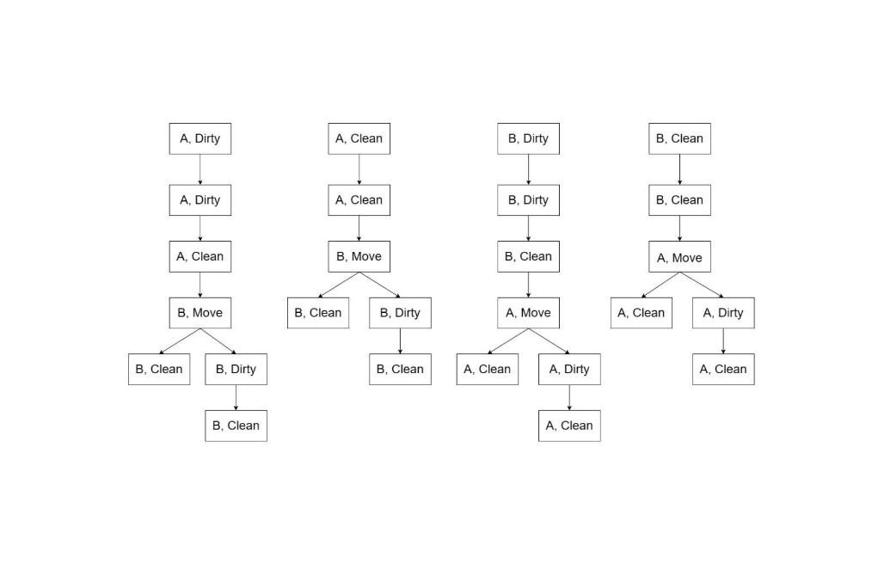

**Goal State:**

The goal of the vacuum cleaner agent is to clean both the boxes A and B i.e. [A, clean],[B, clean] by taking all possible actions.

**Path Cost:**

There are a total of 4 possible paths where each step costs 1 unit.

Path 1 - 5 units.

Path 2- 4 units.

Path 3 - 5 units.

Path 4- 4 units.

For the given example where [A,dirty], the path is:

[A dirty]→[A clean]→[B move]→[B dirty]→[B clean]

Since there are a total of 5 stages; therefore, the path cost is 5 units.

**Conclusion:**

Thus, we have learned to study the structure, characteristics of intelligent agent and identify the type of any rational agent.